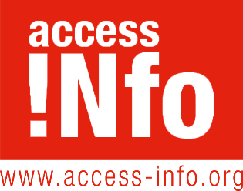
Access Info Europe
Cava de San Miguel 8, 4C
28005, Madrid
Mr Martin Kröger
Head of Unit, Transparency,
European Commission,
Rue de la Loi 200,
1049 Brussels
Belgium
1 September 2016
Dear Mr Martin Kröger,
I am writing on behalf of Access Info Europe to bring to your attention a concern that we have about the way the Commission is treating the right of access to EU documents.
Since the beginning of August, Access Info has noted that people making access to documents requests have received the following automated message from the Secretariat General warning them about possible delays:
“Due to the holiday period in August, some delays may occur in the treatment of your access-to-documents request, especially where the processing of data requires the consultation of national administrations, external organisations or other services.”
Access Info has counted 22 instances of this specific message appearing on the AsktheEU.org request platform.
Access Info finds it unacceptable for citizens to have to anticipate systematic delays because their requests are submitted during the summer months.
The EU’s transparency rules (Regulation 1049/2001) establish that “An application for access to a document shall be handled promptly” and within a maximum 15 day time frame. The rules also provide that extensions should only be applied in “exceptional cases…in the event of an application relating to a very long document or to a very large number of documents” and with “detailed reasons” outlining why.
Since the right of access to information is a fundamental human right recognised by the EU treaties (Article 15(3) TFEU) as well as by international human rights courts and other bodies, it should not become less applicable during the summer than in other months of the year.
Whilst August may see a lower number of staff working in EU institutions, the institution is still bound by the same rules and standards set out in Regulation 1049/2001 and should ensure sufficient staff coverage to ensure that requests are indeed processed promptly. In all cases the application of extensions should be rare and fully justified.
Access Info Europe kindly asks the Secretariat General of the European Commission to confirm how many responses to access to EU documents requests were delayed during August 2016?
Access Info Europe also requests that the Secretariat General of the European Commission confirm whether this notification is a formal policy decision, and if so at what level the decision was taken and with which legal justification?
Yours Sincerely
Helen Darbishire
Executive Director
Access Info Europe

