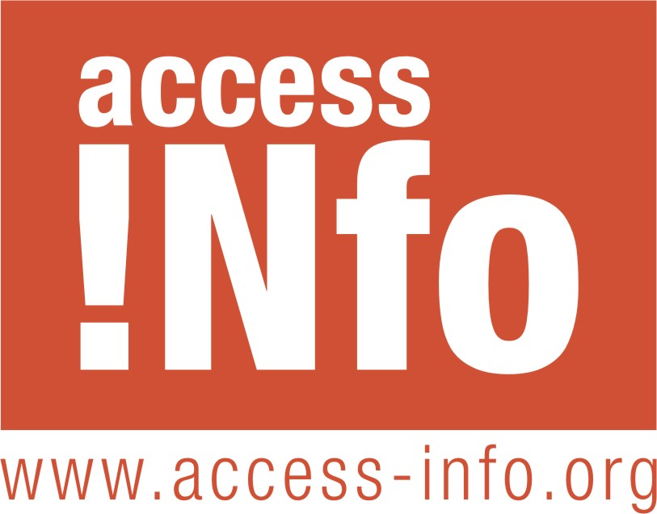
Access Info Europe

European Commission Secretariat General
Unit SG.E3, Transparency, Relations with Stakeholders and External Organisations
e-mail: Sg-Acc-Doc@ec.europa.eu

cc: European Commission, DG Enlargement
e-mail: Marta.Garcia-Fidalgo@ec.europa.eu, ELARG-ACCDOC@ec.europa.eu

Your Ref. ELARG C4/KN dp D(2010)

Madrid, 13 April 2010

Dear Sir/Madam,

This is a confirmatory application submitted in conformity with Article 7(2) of the Regulation (EC) No 1049/2001 of the European Parliament and of the Council of 30 May 2001 regarding public access to European Parliament, Council and Commission documents. You may make this confirmatory application public.

This confirmatory application relates to the refusal by DG Enlargement, in a letter dated 22 Mars 2010, sent by e-mail and received on 23 March 2010, to grant to Helen Darbishire acting on behalf of Access Info Europe (hereafter “Access Info Europe”) access to the replies of Montenegro to the Questionnaire of the European Commission regarding Montenegro’s application for EU membership.

This request has been refused on three grounds:
1. Protection of international relations, Article 4.1 of Regulation 1049/2001.
2. The information relates to a decision that has not yet been taken, Article 4.3 of the Regulation.
3. The Montenegrin government does not intend to make public their replies to the questionnaire.

We believe that these grounds for refusing access are unfounded and that the refusal to grant access is a violation of Access Info Europe’s right of access to documents. We will justify this by addressing each in turn.

1. The international relations exception should only be applied when the disclosure of the information would “undermine protection of ... international relations”. The Commission has not demonstrated how international relations would be undermined by the release the replies to the questionnaire, which we note contains around 30 chapters each with multiple questions (ranging up to 150 or more questions).

Regulation 1049/2001 at Article 4.6 requires that in cases where only part of a document falls under an exception, then “the remaining parts of the document shall be released.” Given that much of the information in the answers is likely to be factual and to be information which is already in the public domain, it is not plausible that the entire questionnaire with answers would undermine international relations if released.

We therefore request that the Commission provide at least partial access to the questionnaire with answers, justifying the withholding of each particular part of the document which is deemed to fall under the protection of international relations exception and explaining why and how the release of that part of the document would undermine international relations.

2. The Commission argues that the replies of Montenegro to the questionnaire relates to a decision has not yet been taken. While it is the case that the Commission has not yet taken a decision on Montenegro’s membership of the European Union, we note that Article 4.3 of Regulation 1049/2001 only permits refusing access to documents where such access would “seriously undermine the institution's decision-making process” and that this protection of the decision-making process shall be balanced against the “overriding public interest in disclosure.” In its reply of 23 March, the Commission has failed to demonstrate how the disclosure of the replies to the questionnaire in their entirety would seriously undermine the decision on Montenegro’s accession. The Commission has also failed to demonstrate that it took into consideration the public interest in access to this information.

Access Info Europe asserts that that the accession of any new member state to the European Union is of paramount public interest for the European public. The transparency of that process is essential to permit public debate around the readiness of a particular country to join the Union. These considerations should prevail and it should be possible for the Commission to conduct its decision-making on this important issue in the light of full public debate and scrutiny.

Two further considerations are relevant here. The first is that parts of the replies to the questionnaire we reported on in the media in Montenegro and in the ensuing debate it was widely argued that not all the statements made in the replies were consistent with the reality of the conditions in Montenegro. That there may be discrepancies between the information contained in the replies and the actual situation in Montenegro is of utmost importance to European citizens. This concern strengthens the public interest in having access to the information.

The second consideration is that in a number of other countries in the Balkans region, the replies to the questionnaire were made available to the public by the governments concerned without any reported negative impact on the Commission’s decision-making process. Indeed, this transparency permitted public debate and the participation of civil society contributing to a more democratic and inclusive process. An example is Macedonia (FYROM) whose replies can be can be accessed at the following url: http://www.sep.gov.mk/prasalnik/ (replies published 14 February 2005, at the same time as they were submitted to the EC). It is reported from Macedonia that the guidelines for answering the questionnaire, and the contact/responsible persons for answering it, were made public before the government received the questionnaire. During the process of drafting the response to the questionnaire, information was available about the status of the draft responses.

Similarly, it has been reported to Access Info Europe that the replies from Croatia were published immediately they were sent to the EC. Likewise in the two most recent members to join the EU, Bulgaria and Romania, information was made available during the pre-accession period. In Bulgaria the government’s answers and positions regarding pre-accession are accessible online on the website of each responsible ministry. For instance, the Bulgarian position on chapter 24 “Justice and home affairs” is uploaded on the website of the Ministry of Interior (http://eu.mvr.bg/en/Progress/negotiations.htm - some sections in English cannot be opened, but in Bulgarian the information is accessible). In Romania the information on the negotiation chapters can be found at http://eufinantare.info/uniuneaeuropeana/capitole_negociere.html and http://www.mie.ro/_documente/arhiva_mie/ro/relatiile_ro_ue/armonizare_legislativa.htm (Access Info Europe does not have information on the precise dates of uploading of the Bulgarian and Romanian information, but civil society groups from these countries report that information was available during the pre-accession period and that in Bulgaria NGOs were regularly invited to discuss problems and express their opinions with the EC delegation in Bulgaria.)

Taking these comparative experiences into account and the clear public interest in having a public debate about the accession process, Access Info Europe believes that there is no justification for the Commission withholding the replies and calls on it to make the relevant documents public.

3. The Commission notes that that the Montenegrin government has indicated to the Commission that it will not be making its replies public. In the 23 March reply received from the DG Enlargement, it seems that two provisions of Regulation 1049/2001 might have been confused here. The first is that Regulation 1049/2001 at Article 4.3 permits member states to “request the institution not to disclose a document originating from that Member State without its prior agreement.” This provision clearly does not apply in this case as Montenegro is not (yet) a member state.

The second is that the Commission is required to consult with third parties when assessing whether an exception contained in paragraph 4.1 or 4.2 (but not in paragraph 4.3) of the Regulation applies to documents received from third parties “unless it is clear that the document shall or shall not be disclosed”. This provision (Article 4.4) does not give third parties the right of veto over a decision to disclose the information. Therefore, the mere fact that the Montenegrin government is reluctant to release the information is not sufficient if the Commission cannot also justify the application of one of the exceptions set out in articles 4.1 or 4.2 of the Regulation. As noted above, the Commission has failed to fully justify the application of the international relations exception and does not appear to have given consideration to at least partial access to the relevant documents.

Access Info Europe notes that it would be of great concern to European citizens if the transparency standards of the European Union were to be set by third countries, especially those which have a poor reputation for transparency, are at best emerging democracies, and which are reported to have high levels of corruption (for example, Montenegro ranks in 69th position in the Transparency International Corruption Perception Index).

Taking all the above factors into consideration, we believe that the Montenegrin government’s replies to the questionnaire should be made available in their entirety so that they can be scrutinised and discussed by members of the public in the European Union and in Montenegro. We call on the Secretariat General to overturn the refusal of DG Enlargement and to grant Access Info Europe full access to these documents.

Yours faithfully,
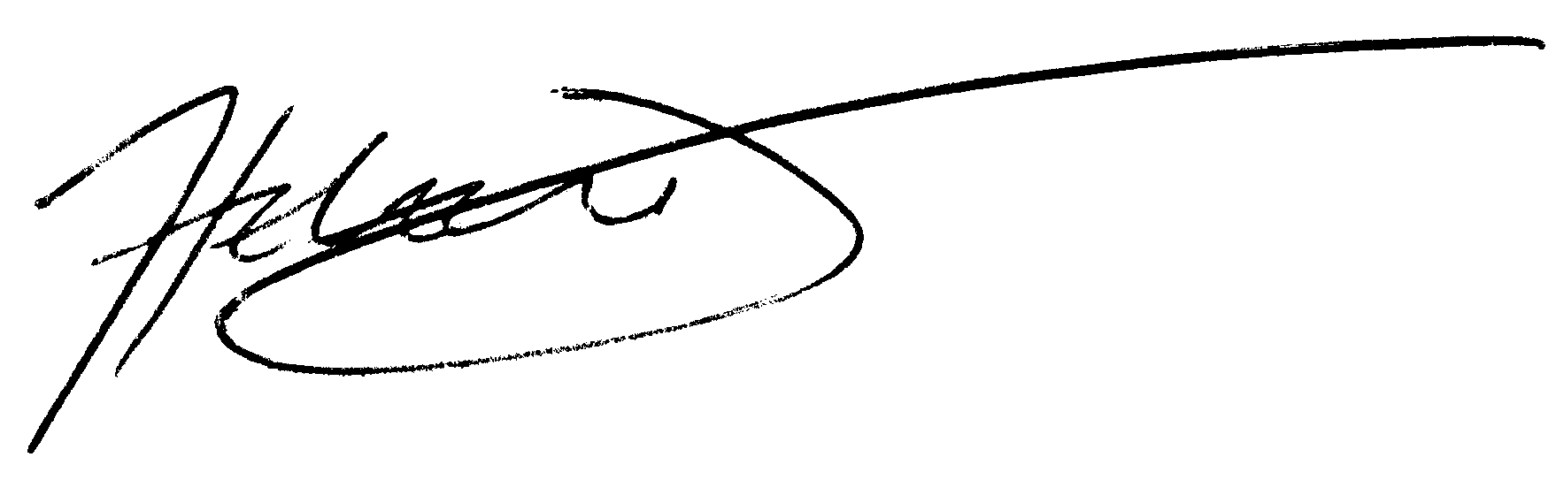
Helen Darbishire
Executive Director
Access Info Europe
Príncipe de Anglona 5, 2c
28005 MADRID, Spain

