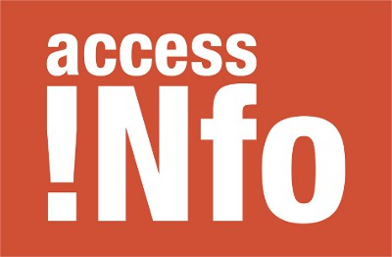

Intervention 27 October – Lydia Medland – Access Info Europe
My name is Lydia Medland and I work for the civil society organisation Access Info Europe, which specialises in the right of access to information.
- Access Info Euope is one of the many organisations that form part of the broad and diverse basis of the UNCAC coalition.

Like many civil society organisations, we play a key role at the local, national and international level helping to ensure that the right of access to information exists both in law and in practice.

With information, citizens, journalists, prosecutors, and civil society organisations can work in partnership with governments to effectively fight against corruption. The right of access to information has been recognised as a human right - and its importance, as we know, is specifically recognised in articles 10 and 13 of the UNCAC.

We urge all governments and governmental bodies that do not already recognise the right of access to information, to do so, and we call on those who are having difficulties implementing access to information or freedom of information laws, to seek assistance from those already modelling best practice.

- We are extremely encouraged by the strong focus and rich debate on civil society participation during this conference. This is particularly taking into account the indispensable role that civil society play in ensuring that the concerns and needs of citizens are reflected at all levels of governmental decision making.

The specific role of civil society organisations of the UNCAC review mechanism is of course recognised in rules 2 and 17 of the Terms of reference of this mechanism. We are optimistic that during the course of this week one of the last doors still closed to transparency in the UNCAC review mechanism will be opened, allowing the participation of civil society in the Implementation Review Group.

- Lastly, we are very pleased to see that many countries are increasingly publishing information relating to corruption on their websites and in other public places, and we hope to see this continuing. In particular we are happy to see that some states have already published their self assessment questionnaires on the UNODC website, and we hope to see more there soon.
All this will help civil society and citizens to join governments in the prevention and fight against corruption.

