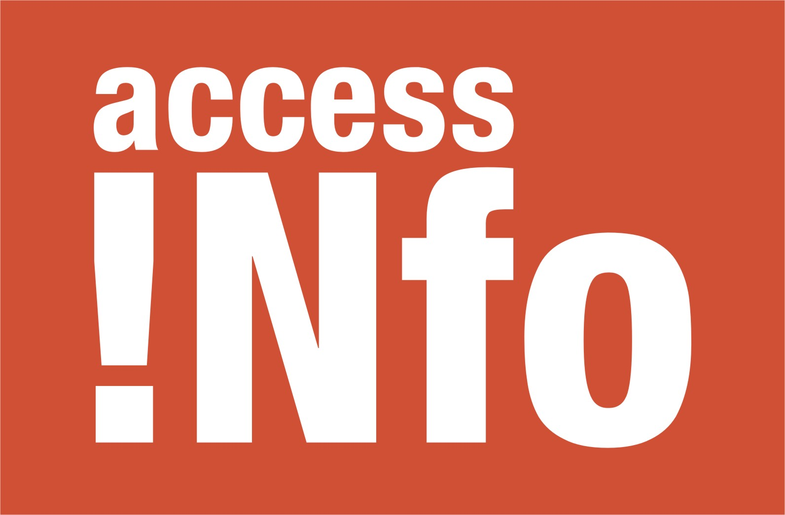
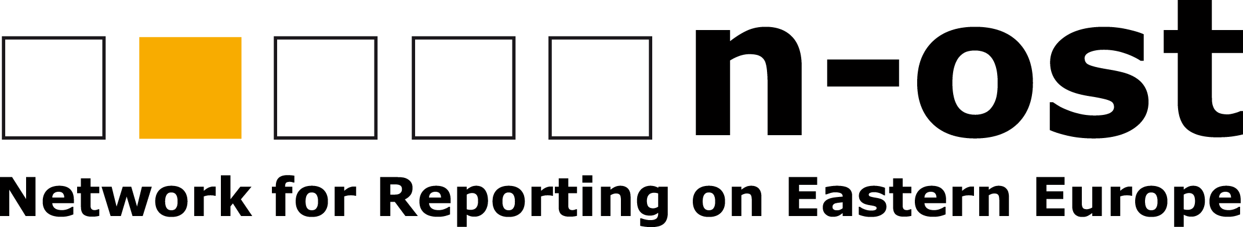
Press release, 3 May 2010

OSCE Representative on Freedom of the Media commits to promote “culture of access to information” and presents Legal Leaks Toolkit

Berlin – The OSCE Representative on Freedom of the Media, Dunja Mijatović, launched a Europe-wide guide for journalists on how to access government information today, marking World Press Freedom Day.

In her first public appearance in Germany and her first World Press Freedom Day since she was appointed March 2010, Mijatovic presented the “Legal Leaks Toolkit” saying she would spare no effort to defend media freedom.

“Promoting a culture of access to information on an international level is an effective method to increase government transparency, while raising awareness and promoting investigative journalism. I will ensure that access to information remains high on the intergovernmental agenda and keep reminding the governments of the OSCE participating States of its importance,” Mijatovic said at a news conference in Berlin.

The “Legal Leaks Toolkit” (copies available at www.legalleaks.info) is a guide for journalists and bloggers on how to make requests for information in 45 countries in the OSCE, including most EU countries, the USA and Canada. Prepared by Access Info (Madrid) and Berlin-based n-ost Network for Reporting on Eastern Europe with OSCE support, it provides journalists and bloggers with 20 Top Tips on how to use the right of access to information as a research tool, particularly for transnational investigations, and gives guidance on how to turn both documents accessed and refusals into stories.

The Legal Leaks project will span several years and integrate training, legal support, and advocacy. Journalists will be supported in filing requests in different countries, given particular assistance to those making transnational requests. Over time the Legal Leaks project will develop a pan-European resource network for use by both local and investigative journalists.

“The Legal Leaks Toolkit not only explains what access to information laws are and how they should be used, but the project will create an international network of journalists who could help each other access information in their respective states,” Mijatović said at a news conference in Berlin.

This year’s World Press Freedom Day has a special focus on the Right to Know, which is the fundamental right of journalists and all citizens to access information held by public bodies. This right is an essential part of the right to freedom of expression anchored in Article 19 of the Universal Declaration of Human Rights.

PRESS CONTACT:
Christian Mihr, Head of Media Policy Projects
n-ost Network for Reporting on Eastern Europe
Neuenburger Straße 17
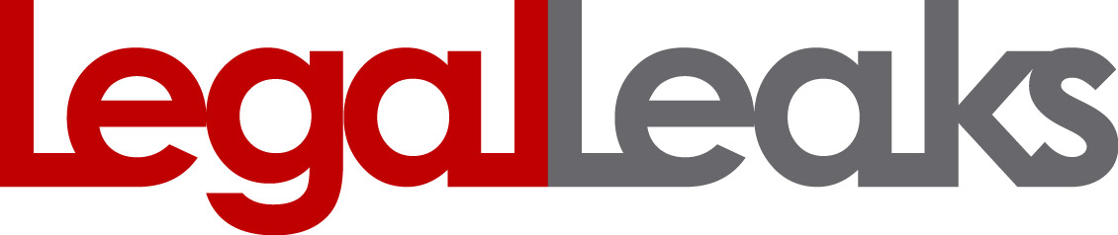
D-10969 Berlin
Tel: +49-30-259 32 83-0
E-Mail: n-ost@n-ost.de

