
ACCESS INFO EUROPE

For immediate release

General Court of the European Union rules refusal illegitimate
Brussels/Madrid, Monday 22 March 2011: The General Court of the European Union today found that the Council of the EU wrongly refused to disclose the identity of countries taking positions on reform of the EU’s access to documents rules.
Ruling on an application brought by Access Info Europe (Access Info Europe v Council, case T-233/09), the Court found that the Council had “in no way demonstrated” how publication of the country names would “seriously undermine its decision-making process”.
The Court stated that “If citizens are to be able to exercise their democratic rights, they must be in a position to follow in detail the decision-making process” and that they should “have access to all relevant information.”
The Council had asserted that: “If written contributions were made fully accessible to the public … positions of the delegations [would] become entrenched, since those delegations would lose some of their ability … to justify before their public a compromise solution, which may differ from their initial position.”
The Court responded that “By its nature, a proposal is designed to be discussed … not to remain unchanged …. Public opinion is perfectly capable of understanding that the author of a proposal is likely to amend its content subsequently.”
Countering the argument put forward by the Council that: “If delegations were deprived of the chance of having calm discussions … it would make it difficult for the Council to move the revision of the regulation forward,” the Court noted that: “it is in the nature of democratic debate that a proposal for amendment of a draft regulation … can be subject to both positive and negative comments on the part of the public and media.”
The Court’s ruling comes a day after Access Info Europe published “The Secret State of EU Transparency Reforms” which demonstrates the need for greater openness in the Council if the public is to follow and participate in the EU legislative process.
“The judgment and the case illustrate that political debate is essential before legislation is adopted”, said Helen Darbishire, Executive Director of Access Info Europe. “This ruling means that the European public will be better informed about and have a say in the decisions that affect our everyday lives,”
For more information – in English or French - please contact:
Pam Bartlett Quintanilla, Researcher, Access Info Europe
pam@access-info.org | +34 699 354 215
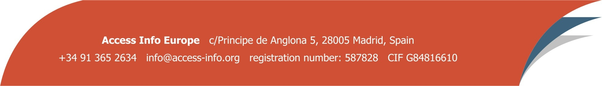
Helen Darbishire, Executive Director, Access Info Europe
helen@access-info.org | +34 667 685 319

