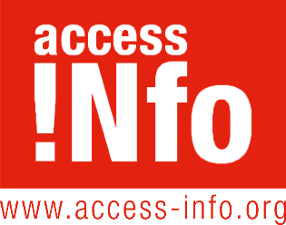
Access Info Europe

Calle Cava de San Miguel 8, 4c

28005 Madrid

ACCESS INFO’S SUPPORT TO LOCAL GOVERNMENT
Access Info is a non-governmental organisation founded in 2006 which specialises in open government, transparency, participation and the fight against corruption.
The Access Info are experts in working with local government in Europe, Latin America, and globally in order to advance with greater transparency, setting up anti-corruption systems and implementing specific integrity measures, and designing and implementing open government action plans.
Access Info has provided consultancy and training for national and local public officials in collaboration with the European Union, the Council of Europe, UNESCO, the OECD, and the Open Government Partnership.
We regularly provide consultancy services to regional and local authorities.
We have run European Commission-funded projects in collaboration with local government bodies in EU countries (most recently working on anti-corruption in local government in Italy, Greece and Spain).
Our team all speak English and Spanish, and some speak French and Italian.

TOOLS for Local Government Bodies
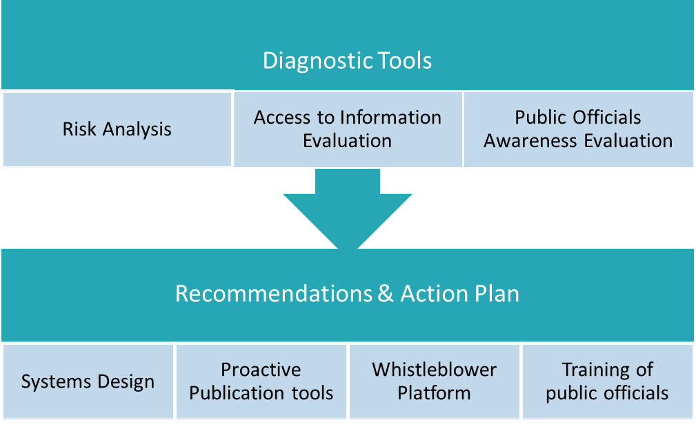
Given the importance for local governments of open and participatory relationships with the public, of building trust, and of reducing corruption, Access Info and partners across Europe have designed a series of tools especially for local government bodies.
These tools comprise our diagnostic tools and our solutions & implementation tools.

The Diagnostic Tools comprise:
- Access to Information Tool: This tool evaluates your levels of transparency and compliance with access to information rules, including proactive publication requirements.
- Corruption risk analysis: This tool evaluates the various mechanisms that need to be put in place to reduce corruption risks.
- Awareness & Attitudes Survey: This tool contains a series of questions about the awareness public officials of the various transparency and anti-corruption mechanisms that your local government body has in place. It will give you a clear picture of the training needs of your team.

The Solutions & Implementation Tools comprise:
- Systems Design: Based on the findings of the Diagnostic Tools, Access Info can design solutions for your municipality, and can provide specific guidance and training to help with the implementation of these systems.
- Integrity Transparency Tool: This tool provides you with a structure for publishing accountability data such as meetings and lobby information,
- Open Procurement Tool: This tool helps you organise and publish data on public procurement in line with the Open Data Contracting Standards (OCDS).
- Whistleblower platform: This digital platform for managing whistleblower alerts, developed by Transparency International Italy, guarantees the anonymity of reports of corruption. It uses free, open source software, and can be adapted to the needs of each municipality.

CONSULTANCY & DESIGN OF SOLUTIONS
In addition to the diagnostic tools, Access Info offers services by which it works with local authorities to design solutions, develop systems, and put in place transparency mechanisms.
- Consultancy on designing accountability and integrity systems, including transparency of agendas and meetings, lobby transparency, and assets declarations transparency.
- Guidance on how to increase transparency in public procurement and how to implement the Open Data Contracting Standards (OCDS).

TRAINING: getting public officials up to speed on open government
Extensive experience of training public officials in many countries in Europe, Latin America and globally.
Our training for public officials includes on topics such as:
- The principles of the right of access to information;
- Exceptions: how to apply limits correctly and how to protect personal data;
- How to design an open government action plan;
- Setting up internal systems for processing access to information requests;
- How to provide assistance to members of the public;
- How to run a public consultation;
- How to work with journalists (including training for spokespersons).
Each of the analytical tools mentioned above – on access to information, risk analysis, public procurement, whistleblowers – comes with a training module.
Access Info can, as necessary, also provide:
- Design and organisation of trainings
- Production of a training videos
- Promotion of event and management of registrations for public events
- Written or video summaries of events for use in your website and social media

GUIDES: for public officials & for citizens
Access Info can work to with you to design guides for either public officials or citizens.
These guides can range from more detailed and technical – such as those that explain internal processes and rules – to clear and accessible informative material (fliers, posters) for members of the public.
Examples of guides we have worked on:
- Guide on how to handle access to information requests
- Guide on how to develop an open government strategy
- Guide on how to evaluate anti-corruption policies
- Guide on rules on public procurement processes
- Guide for citizens on how to make information requests
Once the guides have been written, Access Info can undertake the design, layout and printing of material, should that be necessary.

